OXOT · CYBER DIGITAL TWIN
Model your facility. Simulate the failure. Know where to spend.
OXOT's Cyber Digital Twin is a living engineering model of your facility — not a checklist, not an industry-average score. Change something in the model and see the real consequence: what breaks, what it costs, who's affected. Then fix what actually matters first.
Geometry the plant as built Topology every routed connection
Attributes the cyber & safety record Behaviour what happens when it breaks

WHAT IT IS, IN ONE SENTENCE
Ask your facility a question — and get a real, engineering-grounded answer.

Most security tools watch your network and tell you when something looks wrong. OXOT does something different: it builds an actual model of your facility — every asset, every connection, every safety zone — from your real engineering data. Then you can change that model. Simulate a compromised device. Simulate a vendor going down. Simulate a patch you haven't applied yet. The twin shows you which systems are affected, what it would cost, and what your safety and reliability engineers would actually see happen. That's the difference between an alert and an answer.
Stop guessing where to spend  See the actual exposure on your specific equipment, not an industry benchmark. | Speak one language across teams  Safety, engineering, IT and finance ask the same model different questions and get consistent answers. | Compliance as a byproduct  Your IEC 62443 zones and target security levels update as your facility does — not once a year in a spreadsheet.

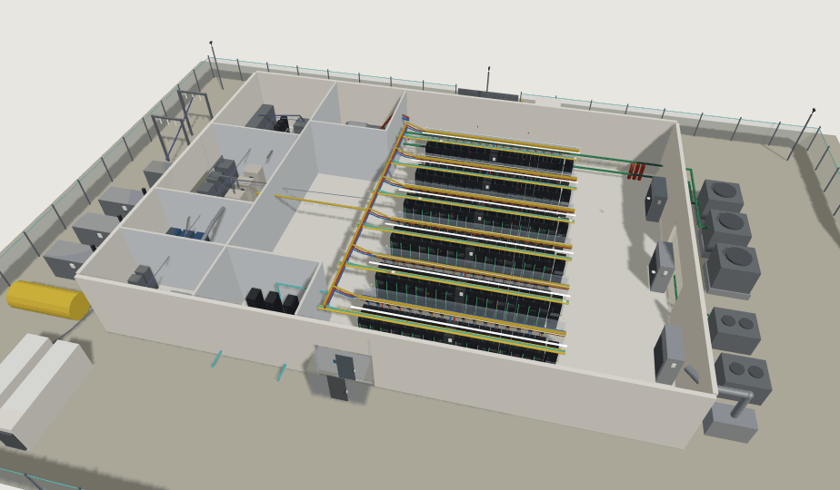
Worked example throughout: a hyperscale AI data centre — 96 racks, 7 engineered systems, 4,000+ named components.

THE PROBLEM

Security tools that don't know what a valve does.
OT and industrial security inherited its playbook from IT — firewalls, patch cadence, network monitoring. None of it was built to understand that patching this system might disable a safety interlock, or that this “low-severity” vulnerability sits on the one asset that would shut down your whole facility if it failed.
THE GAP  A vulnerability scanner can tell you a device is running old firmware. It can’t tell you that device also happens to control cooling for your most critical row of equipment — or that a failure there cascades into three other systems before anyone notices. | WHERE REAL RISK HIDES  That gap — between what a security tool sees and what actually happens on your plant floor — is where real risk hides. Not because anyone missed something. Because the tool was never built to see it in the first place.

WHAT THIS COSTS TEAMS, CONCRETELY
Without a model of physical consequence, every security decision becomes a negotiation nobody can win cleanly: patch now and risk the maintenance window, or wait and carry the exposure. Isolate the system, or keep the safety logic intact. These decisions get made — but usually on judgment and urgency, not on an actual number for what’s really at stake.

WHAT CLOSES THE GAP
Turn the negotiation into a calculation.
A model that understands both sides — the cyber exposure and the physical engineering behind it — changes the question. Not “patch or don’t.”
Here’s what patching costs you.  Maintenance window, load transfer, redundancy lost while the work is live. | Here’s what waiting costs you.  Carried exposure, priced — with the actual number for each side of the decision.

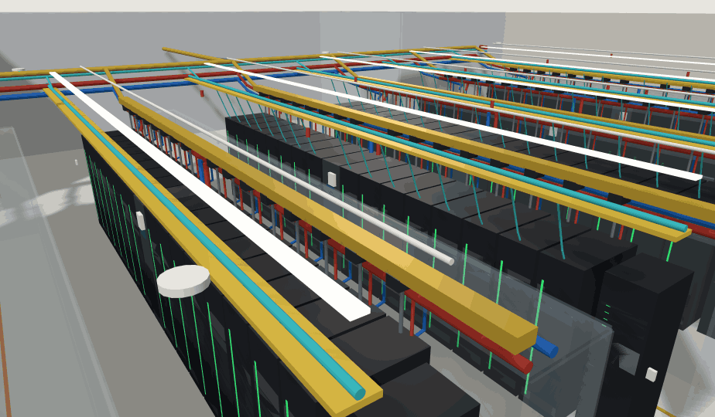

THE MODEL · GEOMETRY AND TOPOLOGY

Selectable to the single tray. Traversable end to end.
Click any object and the twin returns its identity, not a highlight. One 48U liquid-cooled rack resolves to compute trays, switch trays, power shelves, storage, blind-mate coolant couplings and the DC busbar behind them — and every run between them is drawn as an actual routed path between actual endpoints, so dependency is a traversal rather than an assumption.
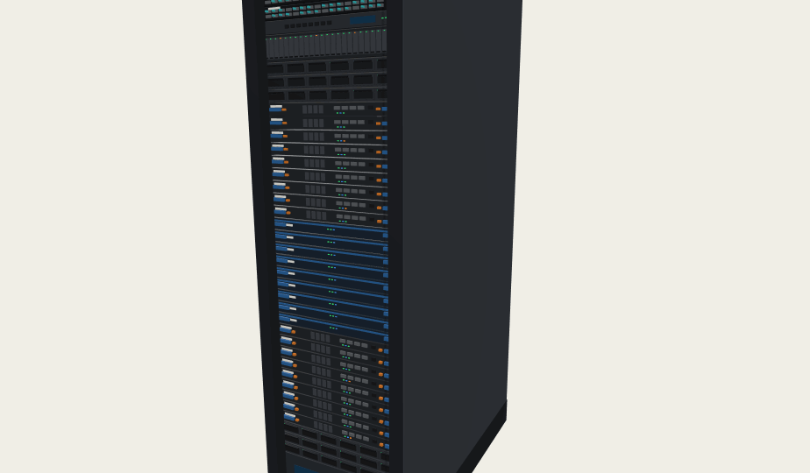
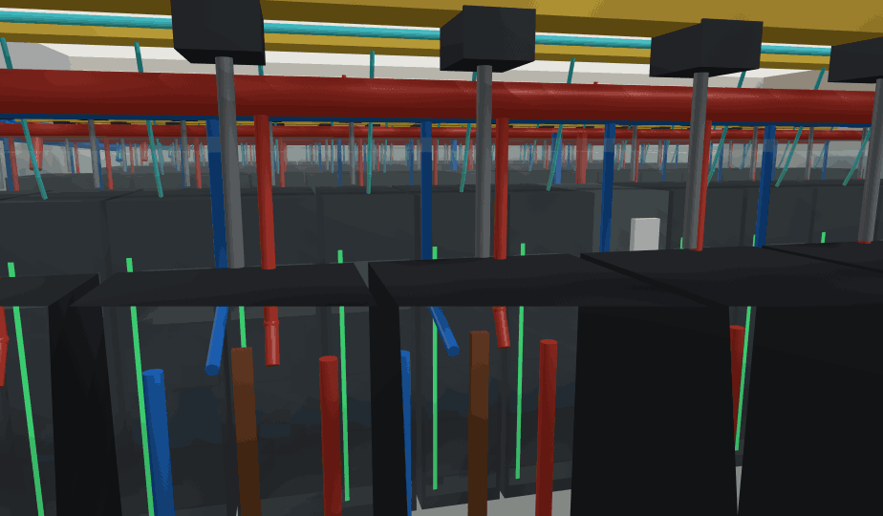
P&ID DISCIPLINE, IN THREE DIMENSIONS
Coolant supply | Plant → CDU → rack manifold
Coolant return | Closed secondary loop per row
Condenser loop | Chiller ↔ cooling tower
Busway & tap-offs | RPP → row → rack
IT fabric | Carrier → core → spine → ToR
OT signal path | Field controllers → OT switch → diode

Power — substation to rack busbar  GIS and MV switchgear, protection relays, transformers, ATS and STS, UPS and battery strings, generators with day tanks and bulk fuel, BESS, RPPs, busway tap-offs — one unbroken chain, with the EPMS metering that watches it. | Thermal — tower to chip  Cooling towers and dry-cooler economisers, chiller plant, primary pumps and VFDs, facility-water spines, row CDUs, rack manifolds and every quick-disconnect — with leak detection and control attached.

WHERE IT STOPS BEING AN ENGINEERING MODEL
The twin carries segmentation as geometry. The IT fabric — carrier entries, ISP routers, perimeter firewalls, core spine, leaf, end-of-row and ToR — and the OT signal path — CDU and chiller PLCs, EPMS, generator controllers, gas sensing and BMS field devices behind a hardened OT switch, OT firewall and one-way data diode — are physically distinct objects. You can see the boundary, and you can see every place something crosses it.

HOW IT THINKS

A real number, not a checklist score.
Most security and compliance tools give you a score against a generic standard — a percentage, a letter grade, a checklist completion rate. OXOT gives you something a budget conversation can actually use: a defensible number, built from your real equipment and its real failure history — not an industry average.
HOW IT'S BUILT  Underneath, the twin runs the same kind of engineering analysis reliability and safety engineers already trust — failure mode analysis, reliability figures, hazard assessment — and combines it with live threat intelligence: which vulnerabilities are actively exploited, which ones matter for your specific equipment, and which ones are just noise. The result isn’t a guess dressed up as a score. It’s a calculation: how likely is this, and what would it actually cost. | WHY GENERIC BEST PRACTICE ISN'T ENOUGH  An industry checklist tells you what most facilities like yours should probably do. It can’t tell you what your facility should do — because it doesn’t know your equipment, your layout, your history. Two facilities can look identical on a compliance checklist and have completely different actual risk. The twin is built from your plant, not a template of one.

For the engineers who want the specifics: FMECA and reliability analysis, IEC 62443 zone and target security-level modelling, and CVE/exploit-intelligence matching, feeding an actuarial-style loss calculation. We’re happy to walk through the full methodology in a briefing.

THE BILL OF MATERIALS · WHAT MAKES THE MATCHING POSSIBLE
Every object carries its own attack surface.
HBOM · hardware  Make, model, revision, firmware level, end-of-support date, supply-chain provenance. | SBOM · software  Components and transitive dependencies in every controller, gateway and appliance image.

CBOM · cryptography  Algorithms, key lengths, certificate expiry, trust anchors and post-quantum exposure. | SaaS & service BOM  Vendor remote access, cloud control planes, telemetry egress and licence dependencies.

CONTINUOUSLY CROSS-REFERENCED AGAINST
CVE / NVD · CISA KEV · EPSS exploit probability · ICS-CERT advisories · Vendor PSIRT · Exploit availability · Threat-actor TTPs · End-of-life status

A CVE alone is noise. A CVE on this controller, reachable through this conduit, holding up this cooling loop, is a decision.

WHAT-IF AND PROBABILISTIC OUTCOMES

Consequence first. Then likelihood.
We define the minimum operating requirements with your engineers before we model a single threat. A scenario only matters if it breaches one of them.
SAFETY  No condition that endangers people or defeats a protective function. | RELIABILITY  Concurrent maintainability and N+1 held on both power and cooling. | MINIMUM OPERATION  The floor below which the service is contractually and legally in breach.

WHAT-IF SCENARIO | MODELLED CONSEQUENCE | MOR
Ransomware reaches the DCIM and BMS head end | Loss of visibility; manual cooling control | Breach
Compromised row-CDU controller stalls both pumps | Thermal runaway in ~90 s at full load | Breach
Malicious firmware in a power-shelf PSU family | Correlated failure across every row at once | Breach
Expired certificate on the OT protocol gateway | Silent loss of telemetry; degraded response | Degraded
Vendor SaaS control plane unavailable 72 hours | No orchestration or remote diagnostics | Degraded

MONTE CARLO · 10,000 ITERATIONS PER SCENARIO
A range of outcomes, not a red square.
Each pathway gets a frequency and an impact distribution — downtime, equipment loss, SLA credits, response cost, regulatory exposure — turned into an annualised loss the business can budget against.
10,000  iterations per scenario | ALE  annualised loss expectancy per pathway | P90  the number the board should hold reserve against | Δ ALE  loss avoided by each candidate control

THE OUTPUT

NOW · NEXT · NEVER
Instead of a queue of alerts ranked by generic severity, you get a ranked list of what to fix, priced in the terms that matter to whoever's asking — downtime hours for operations, euros for finance, safety margin for engineering.
NOW — Reachable, exploited, breaks a minimum requirement.  Known-exploited vulnerability on an asset with a live pathway to a safety or cooling function. Highest loss avoided per euro. Fix inside the change window. | NEXT — Real, but bounded, or the path is long.  Meaningful ALE reduction that does not justify an emergency outage. Scheduled into the next maintenance window, with a compensating control until then. | NEVER — Unreachable, or the fix costs more than the loss.  Accepted with reasoning recorded against the object in the twin. The most valuable column — it is what lets your team defensibly stop working on the other 400 findings.

A WALKTHROUGH · ONE EXPOSED DEVICE, ONE REAL ANSWER
What the twin actually does.
SCENARIO | A data centre's cooling control system — a real IEC 62443 zone, with dozens of connected devices. One of those devices shows up with a known, actively-exploited vulnerability.
TODAY | A typical monitoring tool flags it: “vulnerability detected, high severity.” That’s it. Someone has to figure out, manually, what that device actually does, what it’s connected to, and whether it matters.
ON THE TWIN | The same exposure shows something different: this device sits inside the cooling zone for a specific row of equipment. Simulating a compromise traces the path it could take — what it can reach, what safety margin exists before there’s a real operational consequence, and what it would cost if that path were used. That consequence, not just the severity rating, is what ranks it against everything else.
RESULT | The fix might be the same either way — patch the device. But now it’s not one alert among hundreds. It’s a specific, ranked, justified decision: fix this one first, and here’s why.

Scenario is illustrative — written to demonstrate the mechanic, not presented as a named customer's story.

ONE MODEL, EVERY TEAM

One model. Every team asks it something different.
Today, most facilities run risk decisions on five different spreadsheets that don't talk to each other. The twin is the one place safety, engineering, IT and finance can all look and get an answer that agrees with itself.
Safety | What happens if this fails, and who’s exposed? The actual failure modes and consequences for your equipment — not a generic checklist.
Reliability | Where is the next failure coming from? Real reliability figures, tied to the same model your security team uses.
Operations | What does this change cost me in downtime? The operational impact of a security decision before it happens on the floor.
IT & Security | What’s exposed, and what matters most? Vulnerability, exploit and vendor-risk data matched to your specific assets.
Controls Engineering | Does this touch my interlock logic, or just IT? Which layer — process, control or IT — a given exposure sits in.
Finance | What’s the exposure, and is it worth spending on? Risk as annualised loss exposure — a budget number, not a severity colour.
Procurement & Supply Chain | Which vendors are actually a risk? Supplier exposure scored against real vulnerability and trust data.
Support | What’s the real root cause, and who needs to know? Trace it back through the same model everyone else is using.
Executives | Where should the next euro go? One prioritised view of risk across the facility — not eleven dashboards telling different stories.
Managers | What’s actually getting fixed, and is it working? Remediation tracked against real risk reduction, not ticket close rates.

WHO IT'S FOR
Built for teams running physical infrastructure where a cyber incident has a physical consequence — data centres, manufacturing plants and critical infrastructure. If your organisation has safety engineers, reliability engineers, control systems and a security team who don’t currently share one picture of risk, this is built for you.

WHY OXOT

Not another alert feed. Not another checklist.
Most OT security tools do one of two things well: watch your network for anomalies, or check you off against a compliance standard. OXOT does something neither does — it connects what's exposed to what it would actually cost your specific facility, so you know what to do about it.
Passive monitoring tools | Tell you something changed on the network. Built to detect anomalies — not to tell you what a given exposure would cost, or whether it touches a safety system. Useful for detection. Not built for prioritisation.
Compliance & checklist tools | Tell you whether you match a standard. Built to satisfy an audit — not to reflect what’s actually likely to go wrong on your specific plant, with your specific equipment.
OXOT's Cyber Digital Twin | Starts from your actual facility — assets, connections, safety zones — and computes real engineering risk and financial exposure from it. It doesn’t replace detection or compliance reporting. It’s the layer that turns both into a ranked, defensible answer: what to fix first, and why.

WHERE WE STAND TODAY
OXOT is built by people who've spent their careers in industrial engineering and cybersecurity — not just IT security. We're not going to show you logos we haven't earned yet. If you want to see the methodology, talk to the engineers who built it, or get a reference call with an early customer, ask — we'll set it up.

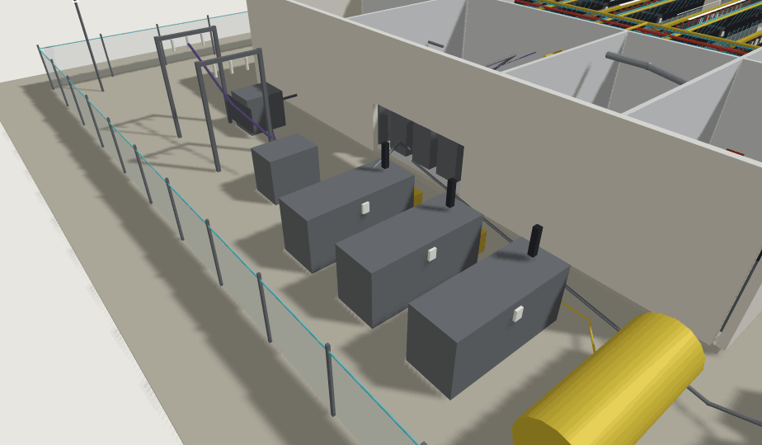
PAIRS WITH
Onboarding a twin normally begins with OXOT Facility Due Diligence — the on-site assessment that establishes the as-is state and produces the four layers the model is built from. See the companion brochure.
You already have the data.
OXOT turns it into a model you can question — and a ranked list of what to do about the answer.
Request a Briefing → See a Sample Report
info@oxot.nl · oxot.nl

